**ASSIGNMENT 19.3**

PROBLEM STATEMENT:

Create a dataframe with 1 to 100 and save as parquet file.

Solution:

(i) Creating a dataframe with 1 to 100

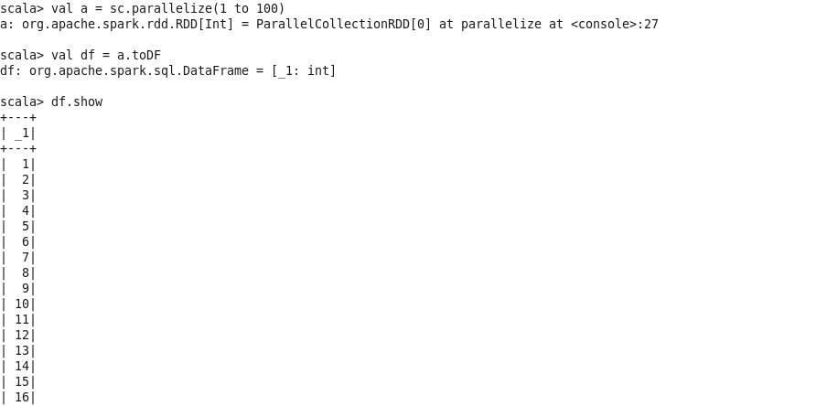

(ii) Saving the dataframe as parquet file.

